Here is a clear step-by-step guide to creating a Django project from scratch

- Install Python
- First, make sure Python is installed: python --version
- If not installed, download it from the official website:
Python Software Foundation
- Create a Virtual Environment (Recommended)
A virtual environment keeps project dependencies isolated.
Create it:
- python -m venv venv
- Activate it:
- On Windows:
- venv\Scripts\activate
- Install Django
- pip install django
- Create a New Django Project
- django-admin startproject myproject
- Replace myproject with your desired project name.
- Move into the project folder:
- cd myproject
- Run the Development Server
- python manage.py runserver
- Open your browser and go to:
- http://127.0.0.1:8000/
- You should see the Django welcome page
- Create a Django App
- Inside your project directory:
- python manage.py startapp myapp
- Example:
python manage.py startapp users
- Register the App
- Open:
- myproject/settings.py
- Add your app inside INSTALLED_APPS:
- INSTALLED_APPS = [
- ...
- 'myapp',
- ]
- Run Migrations
- python manage.py makemigrations
- python manage.py migrate
- Create Superuser (Admin)
- python manage.py createsuperuser
- Then visit:
- http://127.0.0.1:8000/admin/
- Python in web development (frontend/backend)
- Frontend = HTML templates + CSS. Example: crud_app/templates/crud_app/student_form.html.
- Backend = Python views + models. Views handle requests and return templates in crud_app/views.py.
- Frontend <>Backend connection
  - The template form submits to a URL route, which calls a view that saves data.
  - Example: student_create receives POST data, validates with StudentForm, and saves. See crud_app/views.py.
- URL mapping(Connect frontend to backend)
urlpatterns = [
path("", views.student_list, name="student_list"),
path("students/new/", views.student_create, name="student_create"),
path("students/<int:pk>/edit/", views.student_update, name="student_update"),
path("students/<int:pk>/delete/", views.student_delete, name="student_delete"),
]

- Frontend and backend design
- HTML form design
  - The student registration form is built from StudentForm and rendered here: crud_app/templates/crud_app/student_form.html.
- Database design
  - The table schema is the Student model in crud_app/models.py.
  - Each model field becomes a database column.
- Model Database Design
class Student(models.Model):
first_name = models.CharField(max_length=100)
last_name = models.CharField(max_length=100)
email = models.EmailField(unique=True)
registration_number = models.CharField(max_length=30, unique=True)
course = models.CharField(max_length=120)
created_at = models.DateTimeField(auto_now_add=True)
- Insert, retrieve, update, delete

- Insert (Create)
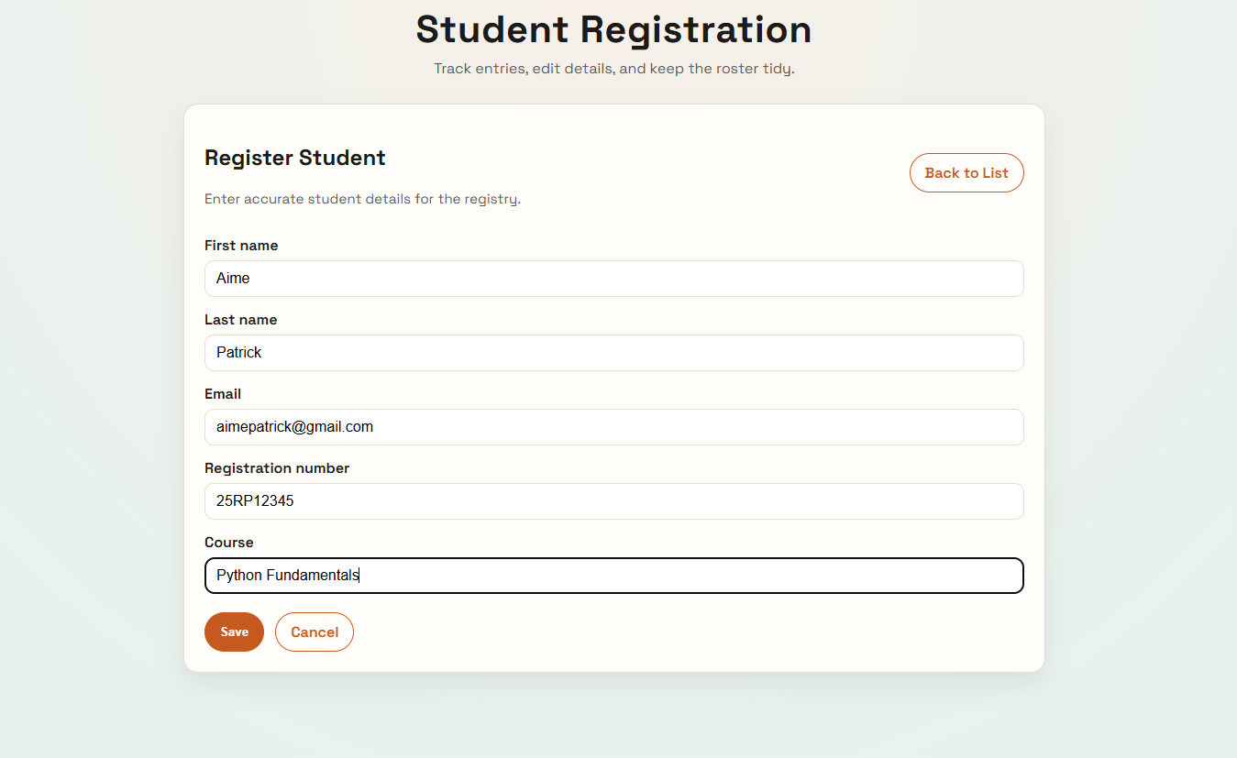
  - View: crud_app/views.py
def student_create(request):
if request.method == "POST":
form = StudentForm(request.POST)
if form.is_valid():
form.save()
return redirect("student_list")
else:
form = StudentForm()

return render(
request,
"crud_app/student_form.html",
{"form": form, "title": "Register Student"},
)

  - Form: crud_app/forms.py
from django import forms

from . models import Student

class StudentForm(forms.ModelForm):
class Meta:
model = Student
fields = [
"first_name",
"last_name",
"email",
"registration_number",
"course",
]
widgets = {
"first_name": forms.TextInput(attrs={"placeholder": "First name"}),
"last_name": forms.TextInput(attrs={"placeholder": "Last name"}),
"email": forms.EmailInput(attrs={"placeholder": "email@example.com"}),
"registration_number": forms.TextInput(
attrs={"placeholder": "e.g. REG-2026-001"}
),
"course": forms.TextInput(attrs={"placeholder": "Course name"}),
}

- Retrieve (Read)
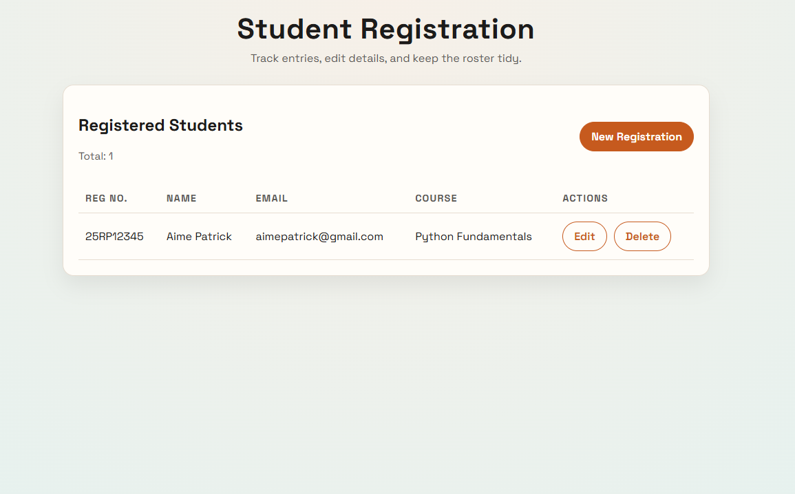
  - View + template: crud_app/views.py, crud_app/templates/crud_app/student_list.html
def student_list(request):
students = Student.objects.order_by("-created_at")
return render(request, "crud_app/student_list.html", {"students": students})

- Update
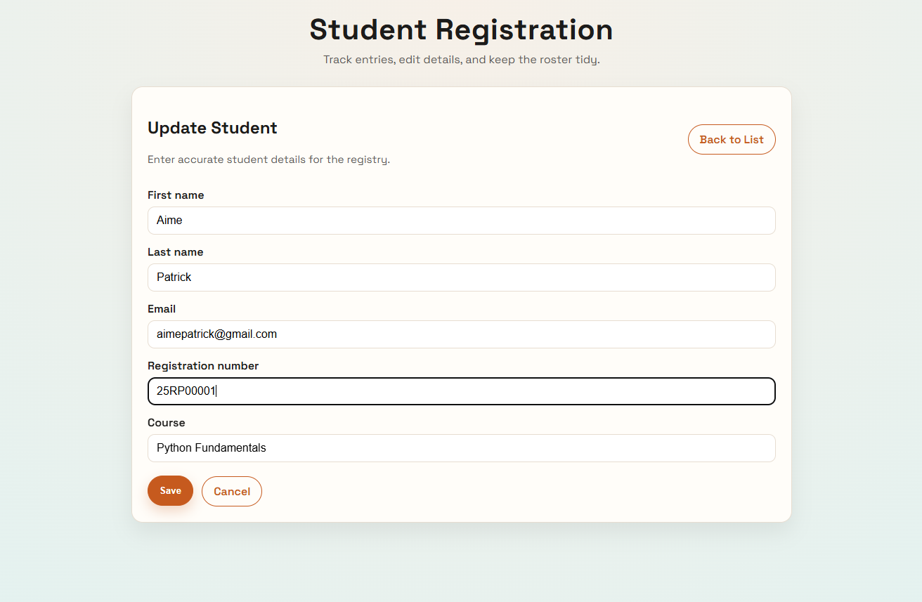
  - View: crud_app/views.py
def student_update(request, pk):
student = get_object_or_404(Student, pk=pk)
if request.method == "POST":
form = StudentForm(request.POST, instance=student)
if form.is_valid():
form.save()
return redirect("student_list")
else:
form = StudentForm(instance=student)

return render(
request,
"crud_app/student_form.html",
{"form": form, "title": "Update Student"},
)
- Delete
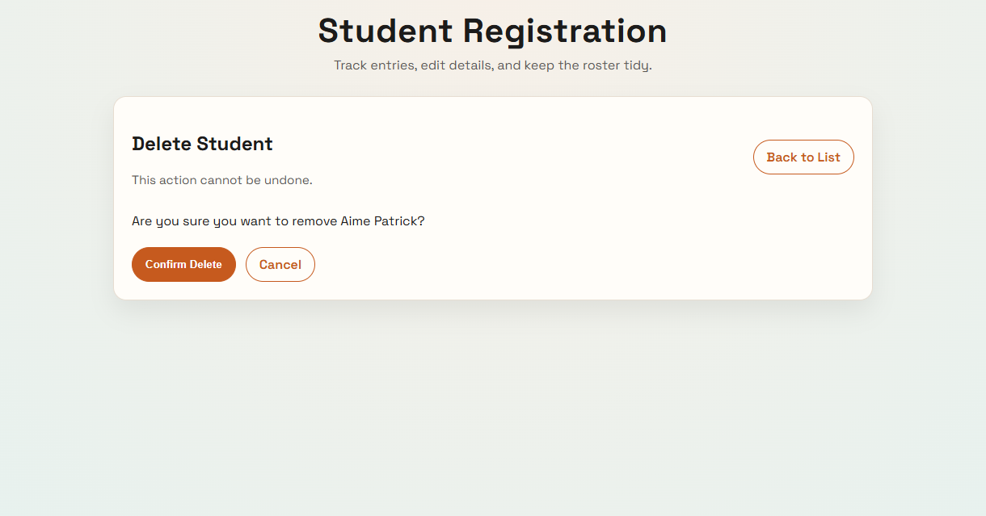
  - View + confirmation page: crud_app/views.py, crud_app/templates/crud_app/student_confirm_delete.html
def student_delete(request, pk):
student = get_object_or_404(Student, pk=pk)
if request.method == "POST":
student.delete()
return redirect("student_list")

return render(
request,
"crud_app/student_confirm_delete.html",
{"student": student},
)

